CREATE TABLE employees2 (

user_id NUMBER PRIMARY KEY,

salary NUMBER,

first_name VARCHAR2(50),

last_name VARCHAR2(50)

);

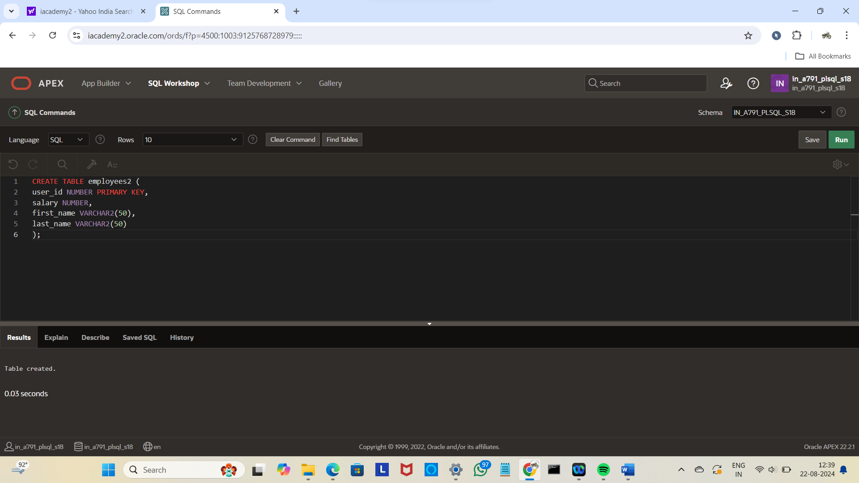

CREATE TABLE log_emp_table (

who VARCHAR2(50),

when TIMESTAMP

);

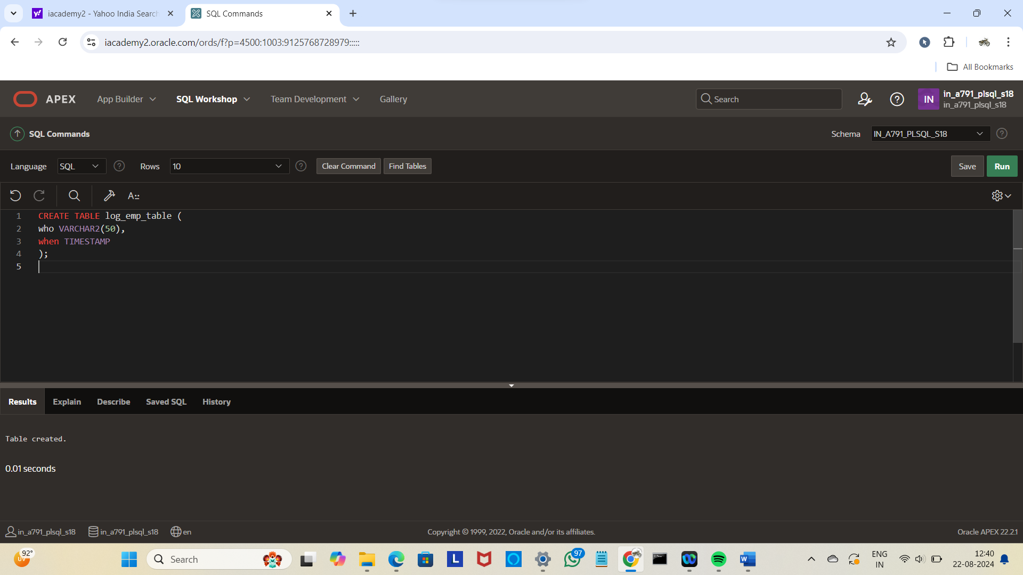

INSERT INTO employees2(user_id, salary, first_name, last_name) VALUES (1, 50000, 'John', 'Doe');

INSERT INTO log_emp_table (who, when)

VALUES ('TestUser', SYSDATE);

INSERT INTO log_emp_table (who, when)

VALUES ('AnotherUser', SYSDATE);

CREATE OR REPLACE TRIGGER log_emp

AFTER INSERT ON employees2

FOR EACH ROW

BEGIN

INSERT INTO log_emp_table (who, when)

VALUES (USER, SYSDATE);

END;

/

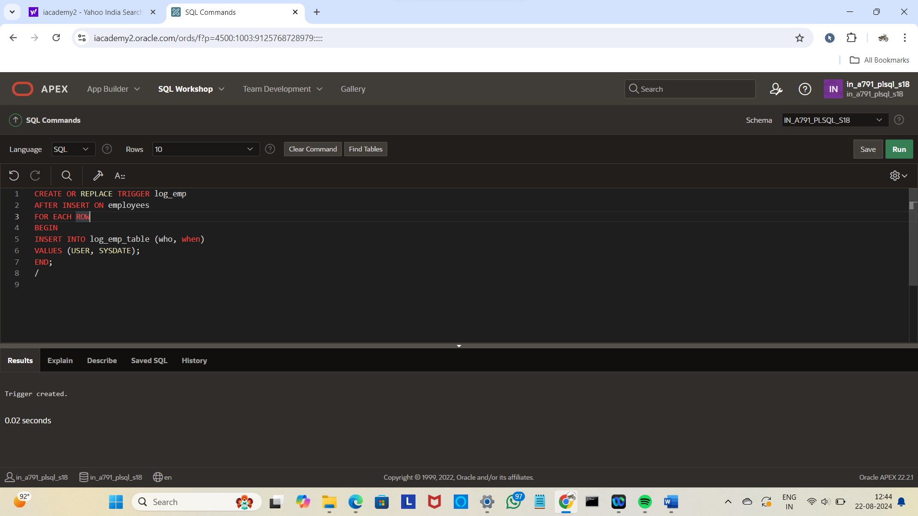

SELECT * FROM log_emp_table;

